Revision Guides for KS4 Subjects – October 2026
SUBJECT: | DETAILS: | LINK TO BUY:
English Language | CGP AQA English Language Revision Guide | https://www.cgpbooks.co.uk/secondary-books/gcse/english/english-lang/enar42-new-gcse-english-language-aqa
English Literature | CGP Macbeth guide to the Text  CGP Romeo and Juliet Guide to the Text  CGP A Christmas Carol Guide to the Text  York Notes A Christmas Carol | https://www.cgpbooks.co.uk/secondary-books/gcse/english/english-lit/etm44-tbc-new-grade-9-1-gcse-english-shakespeare-t  https://www.cgpbooks.co.uk/secondary-books/gcse/english/english-lit/etr45-tbc-new-grade-9-1-gcse-english-shakespeare-t  https://www.cgpbooks.co.uk/secondary-books/gcse/english/english-lit/etcc42-tbc-new-grade-9-1-gcse-english-text-guide-a  https://www.yorknotes.com/gcse/english-literature/a-christmas-carol-2017/overview
Maths | CGP revision guide (higher or foundation) available from the Maths office for £3  Edexcel revision guide (higher or foundation) £5.99  Edexcel revision workbook (higher or foundation) £5.99 | REVISE Edexcel GCSE (9-1) Mathematics Higher Books  REVISE Edexcel GCSE (9-1) Mathematics Foundation Guided Revision Books
Combined  Science | GCSE Combined Science Course (Years 10 and 11)  Foundation Students (sets 2, 3 & 4)  Revision cards, at £8 per pack, can be found here https://www.cgpbooks.co.uk/secondary-books/gcse/science/combined-science/scaf41-gcse-combined-science-aqa-revision  Revision book, at £11, can be found here https://www.cgpbooks.co.uk/secondary-books/gcse/science/combined-science/scafs42-new-gcse-combined-science-aqa  Higher students (set 1)  Revision cards, at £8 per pack, can be found here https://www.cgpbooks.co.uk/secondary-books/gcse/science/combined-science/scaf41-gcse-combined-science-aqa-revision  Revision book can be found here, at £11, https://www.cgpbooks.co.uk/secondary-books/gcse/science/combined-science/scahs42-new-gcse-combined-science-aqa-higher
Separate Sciences | GCSE Separate Science Course (Years 10 and 11)  Biology revision cards, at £4.50 per pack, can be found here https://www.cgpbooks.co.uk/secondary-books/gcse/science/biology/baf41-9-1-gcse-biology-aqa-revision-question  Biology revision book, at £5.50, can be found here https://www.cgpbooks.co.uk/secondary-books/gcse/science/biology/bas46-new-gcse-biology-aqa-complete-revision  Chemistry revision cards, at £4.50 per pack, can be found here https://www.cgpbooks.co.uk/secondary-books/gcse/science/chemistry/caf41-9-1-gcse-chemistry-aqa-revision  Chemistry revision book, at £5.50, can be found here https://www.cgpbooks.co.uk/secondary-books/gcse/science/chemistry/cas46-new-gcse-chemistry-aqa-complete  Physics revision cards, at £4.50 per pack, can be found here https://www.cgpbooks.co.uk/secondary-books/gcse/science/physics/paf41-9-1-gcse-physics-aqa-revision-question  Physics revision book, at £5.50, can be found here https://www.cgpbooks.co.uk/secondary-books/gcse/science/physics/pas48-new-gcse-physics-aqa-complete-revision  If your child follows the Separate Science course, you have the option to purchase resources for all three sciences or just the ones your child feels they need more help with.  All separate science students should purchase the higher tier resources.
History | There are 2 options:  - These individual guides condense the textbooks we have used in lessons. They are well laid out and have lots of pictures and charts etc to display the information.  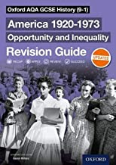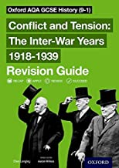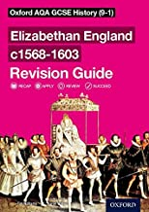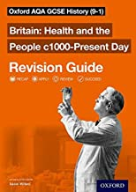  - This book has all 4 components of the course included. It is denser text and has fewer pictures, diagrams etc.  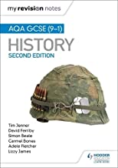 | They are all available on Amazon:  Amazon.co.uk: Gcse Aqa Revision Guide HISTORY  Amazon.co.uk: Gcse Aqa Revision Guide HISTORY  Amazon.co.uk: Gcse Aqa Revision Guide HISTORY  Amazon.co.uk: Gcse Aqa Revision Guide HISTORY  Amazon.co.uk : gcse history aqa hodder
Geography | The main resources we recommend are the CGP Complete Revision and Practice Guide and CGP Revision Question Cards:  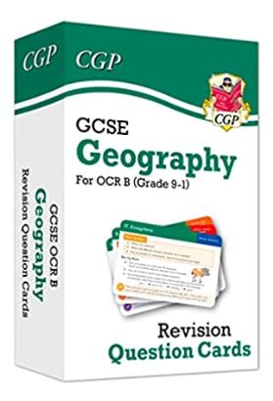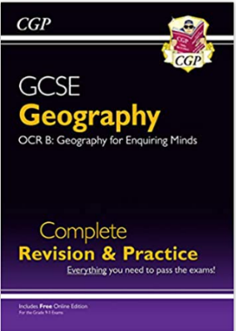  Or the Oxford Revise Complete Revision and Practice.  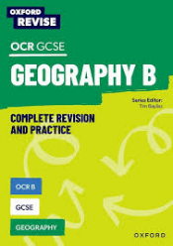  There are many other good revision books available, just ensure they are for the OCR B exam board. | They are both available on Amazon:  GCSE Geography OCR B Revision Question Cards: superb for the 2023 and 2024 exams (CGP OCR GCSE Geography) : CGP Books, CGP Books: Amazon.co.uk: Books  GCSE Geography OCR B Complete Revision & Practice (with Online Edition): superb for the 2023 and 2024 exams (CGP OCR GCSE Geography) : CGP Books, CGP Books: Amazon.co.uk: Books  OCR B GCSE Geography Complete Revision and Practice (Oxford Revise: Geography): Amazon.co.uk: Priest, Rebecca, Bayliss, Tim: 9781382039895: Books
French | AQA French revision guide 9-1 | GCSE French AQA Complete Revision & Practice: with Online Edition & Audio (For exams in 2025) (CGP AQA GCSE French)
German | AQA German revision guide 9-1 | GCSE German AQA Complete Revision & Practice: with Online Edition & Audio (For exams in 2025) (CGP AQA GCSE German)
Spanish | AQA Spanish revision guide 9-1 | GCSE Spanish AQA Complete Revision & Practice: with Online Edition & Audio (For exams in 2025) (CGP AQA GCSE Spanish): Amazon.co.uk: CGP Books, CGP Books: 9781782945482: Books
Business | Pearson REVISE Edexcel GCSE Business Revision Guide inc online edition and quizzes - 2023 and 2024 exams  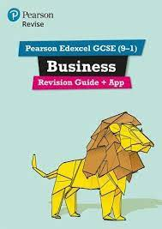  Pearson Edexcel GCSE (9-1) Business Revision Workbook  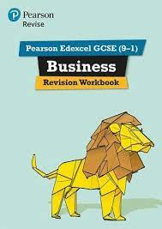  Pearson REVISE Edexcel GCSE Business Revision Cards  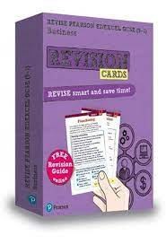 | Pearson REVISE Edexcel GCSE Business Revision Guide inc online edition and quizzes - 2023 and 2024 exams: for home learning, 2022 and 2023 assessments and exams (REVISE Edexcel GCSE Business 2017) : Amazon.co.uk: Books  Pearson Edexcel GCSE (9-1) Business Revision Workbook: Catch-up and Revise: for home learning, 2022 and 2023 assessments and exams (REVISE Edexcel GCSE Business 2017) : VV., AA.: Amazon.co.uk: Books  Pearson REVISE Edexcel GCSE Business Revision Cards (with free online Revision Guide) - 2023 and 2024 exams: for home learning, 2022 and 2023 assessments and exams (REVISE Edexcel GCSE Business 2017) : Redfern, Andrew: Amazon.co.uk: Books
Enterprise & Marketing | Cambridge National in Enterprise and Marketing Revision Guide and Workbook with Digital Access (2 Years): Level 1/Level 2 (Cambridge Nationals)  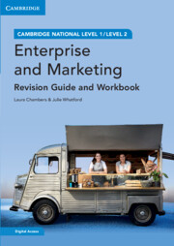 | Cambridge National in Enterprise and Marketing Revision Guide and Workbook with Digital Access (2 Years): Level 1/Level 2 (Cambridge Nationals) : Chambers, Laura, Whatford, Julie: Amazon.co.uk: Books
GCSE PE | Revision Book – AQA GCSE PE | GCSE Simplified - GCSE Physical Education, Revision Study Guide
Engineering TECH | Cambridge National Level 1/Level 2 Engineering Second Edition J822 ISBN: 978-1-3983-5033-5  All students have access to the online version | Level 1/Level 2 Cambridge National in Engineering Design (J822): Second Edition: Amazon.co.uk: Adams, Jonathan, Valentine, Peter, Reynolds, Alex: 9781398350335: Books
Food Prep | AQA Food Preparation & Nutrition textbook (Illuminate Publishing)  Collins AQA Grades 9-1 Food Preparation & Nutrition ‘Complete Revision and Practice’ | FREE....school subscription paid for! Link on school homepage and students have log on details.  Collins GCSE Grade 9-1 Revision - AQA GCSE 9-1 Food Preparation & Nutrition Complete Revision & Practice: Ideal for home learning, 2023 and 2024 exams (Collins GCSE Grade 9-1 Revision): Second edition  £10.99
D&T (including the textiles option) | Students have a copy of this book already so there is no need to buy it. Their copy might currently be in school but they will be able to take it home to revise. If students do not have one they should see their D&T teacher.  Note: it is the same book for textiles and the ‘wood/metals/plastics’ courses. | Collins GCSE Grade 9-1 Revision - AQA GCSE 9-1 Design & Technology Complete Revision & Practice: Ideal for home learning, 2023 and 2024 exams (Collins GCSE Grade 9-1 Revision): Second edition
Media | Copies are available in K14/K15 to use in school (lunch time or after school). | https://www.illuminatepublishing.com/product/wjec-eduqas-gcse-media-studies-student-book-revised-edition
RE | 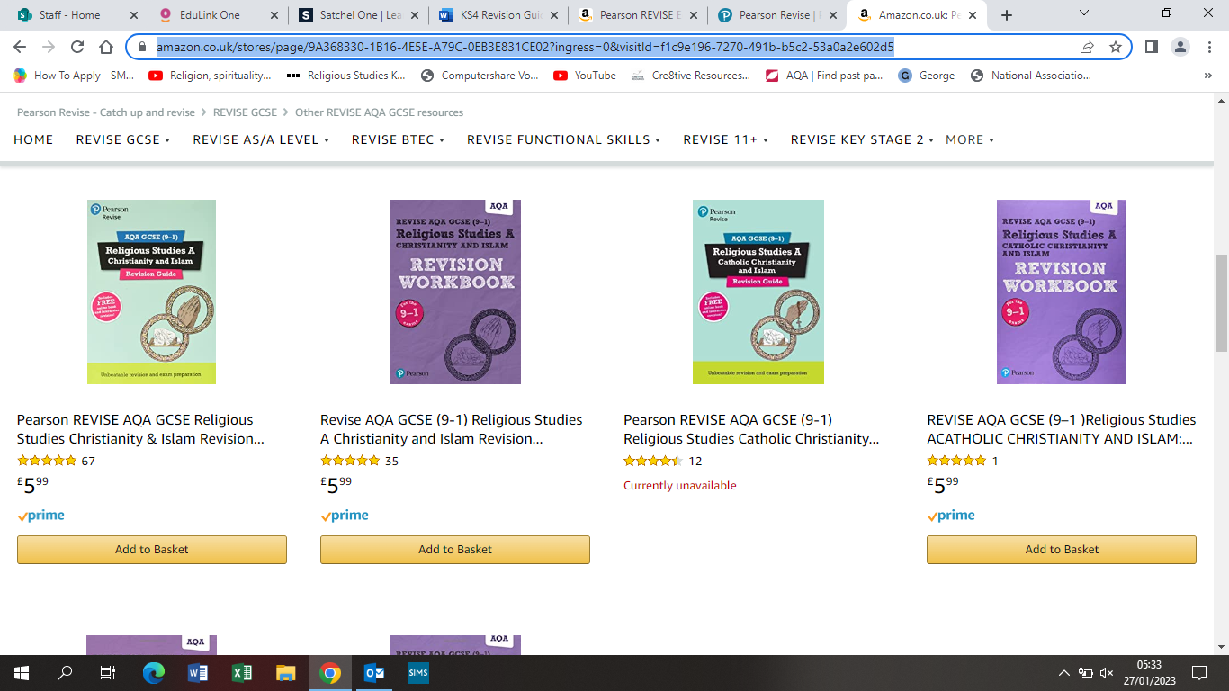  Revision Guide and a workbook containing practice exam questions (including the answers so they self-assess) is available from the Pearson shop on Amazon | https://www.amazon.co.uk/stores/page/9A368330-1B16-4E5E-A79C-0EB3E831CE02?ingress=0&visitId=f1c9e196-7270-491b-b5c2-53a0a2e602d5
Computer Science | 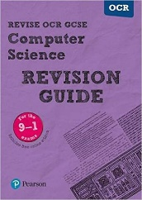  Students already have a copy of this Revision guide and no need to purchase it.  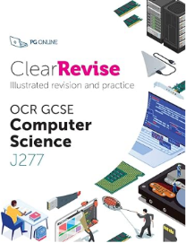  A newer updated version for the J277 course - £8 | https://www.amazon.co.uk/Revise-Computer-Science-Revision-Guide/dp/1292133902/ref=sr_1_1?crid=274QWVG78S9GD&keywords=ocr+computer+science+gcse+9-1+revision+guide+pearson&qid=1675064673&sprefix=ocr+computer+science+gcse+9-1+revision+guide+pearson%2Caps%2C170&sr=8-1  https://www.amazon.co.uk/ClearRevise-GCSE-Computer-Science-J277/dp/1910523232/ref=sr_1_1?crid=VOV03FC4WH5H&keywords=clearrevise+ocr+computer+science+j277&qid=1697530749&sprefix=ClearRevise+J277%2Caps%2C104&sr=8-1
GCSE Dance | Various online resources, links attached | https://www.rbo.org.uk/schools/resource/infra-gcse-dance-resources - Infra resource pack  https://studyrocket.co.uk/revision/gcse-dance-aqa - study rocket  https://www.jamescousinscompany.com/product-page/scheme-of-work - Within Her Eyes  https://rambert.org.uk/classroom/appreciate/aqa-set-works/a-linha-curva/a-linha-curva-gcse-resource-pack/a-linha-curva-resource-pack/ - A linha Curva resource pack  https://arts-pool.co.uk/product/guide-to-artificial-things/ - Artifical Things

